Setting up your Julia Environment on a Computer

*Note: this guide will not work for installing Julia on a tablet such as an iPad. To run julia notebooks on a tablet, an external service such as illumidesk must be used.*

**1. Installing Julia**

Navigate in your web browser to <https://julialang.org/downloads/> and find your operating system under “Current Stable Release”. You most likely want the 64-bit version and the “installer” if on Windows. Download the program, follow the installation instructions and then run the Julia program. If you have installed it correctly you should have the Julia interactive prompt appear like this.

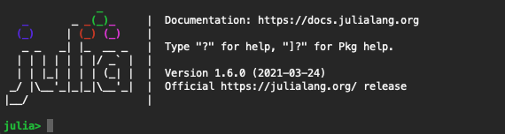

From this prompt you can run simple julia statements and it will print the output to you:

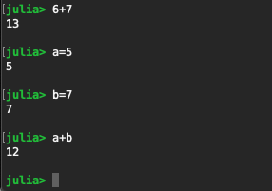

**2. Installing Jupyter**

With Julia installed, we are ready to write and run our Julia programs! Because writing software can be complicated, we often use specially designed code editors to write our code. Jupyter is a web-based editor that is popular with the data-science community. It’s name comes from **Ju**lia, **Pyt**hon and **R**, three languages that are popularly used with it. It's so popular in fact that Julia provides a way to install it right from the Julia Interactive Prompt. To install Jupyter:

**A) Install IJulia**

Press the “**]**” (right square bracket) key in the julia prompt. It is generally two keys right of “P”.

This should bring up the package settings that looks like this:



Type “add IJulia” and press enter. This will install the IJulia package. A package is just a collection of julia programs that someone has made available on the internet so others can use it. When installing IJulia, it will install other packages that its code depends on.

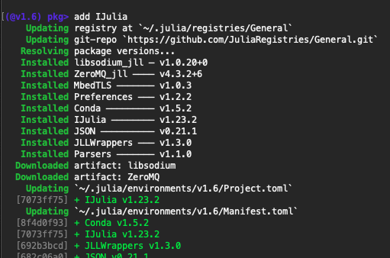

Your version numbers may be different than what is shown. After IJulia finishes installing, press the **backspace** key to close the Package settings and return to the julia prompt.

**B) Install Jupyter Notebook**

Now that we have IJulia installed, we want to load it in our prompt. We do this by typing “using IJulia” at the julia prompt and pressing enter. Next type “notebook()” to launch Jupyter! The first time you do this, it will ask you if you want to install jupyter. Type yes and press enter.



This may take a few minutes the first time while it downloads and installs jupyter, but will be quicker in the future. From now on, to launch Jupyter, you only need to type “using IJulia” and “notebook()”.

After it is installed, it will launch a window in your web browser that looks like this.

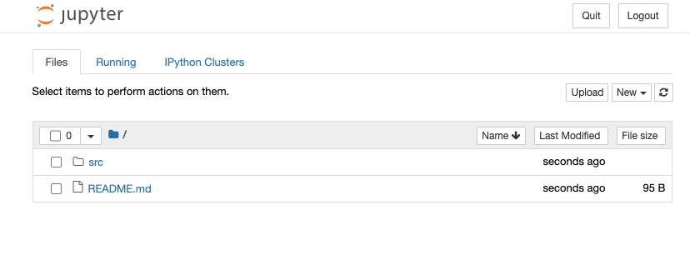

This is the jupyter file viewer. It lets you navigate your documents and create new julia notebooks. We can either navigate to a file that ends in “.ipynb” and double click on it to open it, or create a new notebook with the new button.

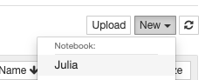

After opening an existing notebook, or creating a new one, a new tab will open where you can run and edit julia notebooks that looks like this:

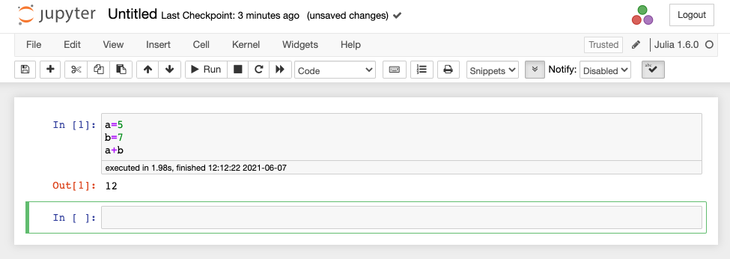

Here are some quick notebook basics. Each rectangle next to “In[]” is called a code cell. You can type julia statements in the code cell and then press “Shift+Enter” to run the cell or just press the “Run” button in the toolbar. Jupyter will print the output of whatever is the last line in a code cell. The green rectangle indicates the currently selected cell.

**References**

The Official Julia Website (<https://julialang.org/>)

IJulia installation documentation (<https://julialang.github.io/IJulia.jl/stable/manual/running/>)

Jupyter Notebooks documentation (<https://jupyter-notebook.readthedocs.io/en/stable/notebook.html>)